NARROGIN SENIOR HIGH SCHOOL

YEAR 11 ECONOMICS
SEMESTER 2 – 2006

Reading Time before commencing: Ten minutes
Working of paper: 2 ½ hours

MATERIAL REQUIRED / RECOMMENDED FOR THIS PAPER

TO BE PROVIDED BY THE SUPERVISOR

This Question Paper comprising 12 pages and 37 questions
A separate Multiple Choice Answer Sheet
Standard Answer Book

TO BE PROVIDED BY THE CANDIDATE

Standard Items – Pens, pencils, eraser, ruler & calculator

**IMPORTANT NOTE TO CANDIDATE**

No other items may be taken into the examination room.

It is your responsibility to ensure that you do not have any unauthorised notes or other items of a non-personal nature in the examination room. Please check carefully and, if you have any unauthorised material with you, hand it to the supervisor BEFORE reading any further.

INSTRUCTIONS TO CANDIDATES

This paper is in THREE (3) sections:

SECTION A:
Attempt ALL questions (30 questions = 30 marks)
Answer ALL questions in Section A (nos. 1-30) on the separate Multiple Choice Answer Sheet.

SECTION B:
Attempt all THREE (3) Questions (3 questions = 30 marks)
Answers to be written in the spaces provided in this section of the paper.

SECTION C:
Attempt TWO (2) Questions (2 questions = 40 marks)
Answers to be written on the lined paper provided.

SECTION A: MULTIPLE CHOICE

Answer ALL questions on the answer sheet provided by placing a cross (X) over the correct choice. Choose the alternative which most correctly answers the questions or completes the statement.

Suggested time for this section is 40 minutes

1 The economic problem implies that
- since scarce resources have many different alternative uses, opportunity cost must be maximised.
- limited needs and wants and scarcity of resources require that rational choices are made by firms, governments and consumers.
- while many resources are plentiful, they may be relatively scarce when compared to society’s unlimited wants.
- resources should be allocated so that all society’s needs and wants can be satisfied.

2 Which of the following is not an important factor influencing the labour force?
- education and training.
- physical strength of workers.
- immigration.
- personal qualities.

3 In the circular flow model of the economy, which of the following are leakages?
- taxation and government spending.
- investment and imports.
- imports and taxation.
- exports and saving.

4 In the circular flow model a closed economy would mean there would be no
- overseas sector.
- finance sector.
- government sector.
- household sector.

5 The most important guiding principle underlying the operation of a market economy is
- the principle of self interest
- the goal of making money.
- consumer sovereignty
- private property ownership.

6 An increase in the cost of making a product would
- shift the supply curve to the right.
- Shift the supply curve to the left.
- shift the demand curve to the right.
- shift the demand curve to the left.

7 Which one of the following is not a factor affecting price elasticity of demand?
- the availability of substitutes.
- the durability of the product.
- income.
- the price of the product as a proportion of the consumer’s income

8 A pure public good is one
- which is provided by government and the private sector.
- where consumption is not competitive and the exclusion principle does not apply.
- where consumption is competitive and the exclusion principle does apply.
- all of these.

9 The decline of a low-skill, labour intensive manufacturing industry will cause unemployment. This type of unemployment is termed
- frictional unemployment.
- structural unemployment.
- cyclical unemployment.
- seasonal unemployment.

10 Of the following, the most important response to unemployment is:
- more investment in eduction and training programs.
- more welfare spending to assist the unemployed.
- birth control among the unemployed because unemployed people tend to have unemployed children.
- to cut back on immigration which causes unemployment among Australians.

11 If the CPI is 125 in one year and the following year is 130 then inflation over the second year
- is 3.8%
- is 125%
- is 4%
- cannot be calculated

12 The CPI measures
- quarterly price rises in a selection of goods and services consumed by the average Australian household.
- quarterly price changes in all goods and services produced in the economy.
- quarterly price changes for a basket of goods and services consumed by the average Australian household.
- quarterly changes in the quantity of goods and services consumed by Australian families.

13 If nominal GDP for a particular year is $345 billion and the deflator is 115 for that year, then real GDP is
- $396.75 billion.
- $300 billion.
- $460 billion.
- $230 billion.

14 Nations trade with each other because
- they don’t produce enough of all the products they want and need.
- trade helps less developed countries raise their living standards and develop their economies.
- resource endowments vary between countries which creates opportunity cost differences in production.
- all of these.

15 When the value of imported goods and services exceeds the value of exported goods and
services the result is a
- deficit on the balance on goods.
- surplus on the balance on the current account.
- deficit on the balance on goods and services.
- surplus on the balance on goods and services.

16. The Key factors influencing the type of production carried out on farms are:
- local seasonal and environmental conditions.
ii) the productivity of farm inputs such as labour and capital
iii) the time lags involved in producing the output.
iv) the expected level of profit.

(a) (i) (b) (ii) and (iii) (c) (iii) and (iv) (d) All of the above

17. The farmer’s choice of factor mix will depend on:
- the productivity of the factor.
- the price of the factor of production.
- the price received for the final product.
- All of the above

18. Which of the following would lead to a decrease in the supply of lamb on the Australian market?
  - the introduction of higher abattoir fees..
  - an increase in the price of beef.
  - a ban on live sheep exports
  - drought conditions.

- (iii) and (iv)
- (i) and (iv)
- (ii) and (iii)
- (i), (ii), (iii) and (iv)

19. An increase in the demand for wool is likely to result from:
  - a successful ‘wool mark’ promotion campaign.
  - a decrease in the price of synthetic fibres.
  - a decrease in real income.
  - a reduction in the supply of wool.

20. What effect would a very favourable growing season have on the supply, demand and price of avocadoes?
    - an increase in supply of and demand for avocadoes, with no change in price.
    - an increase in supply of avocadoes, demand remains unchanged, and a fall in price.
    - an increase in the supply of avocadoes, a decrease in demand, and a small fall in price.
    - an increase in demand for avocadoes, supply remains unchanged, and a rise in price.

21. Time lags in farming:

- eliminate shortages and surpluses occurring in production.
- result in uncertainty and instability in agricultural markets.
- enable farmers to predict future profits with greater accuracy.
- delay the impact of diminishing returns.

22. A decline in the value of agricultural products, as a percentage of total exports since the late 1950s has been mainly due to:
- a decrease in the number of people employed on farms.
- a decline in productivity of the agricultural sector.
- the growth of exports from the mining and manufacturing sectors.
- the effects of environmental factors such as drought and salinity.

23. The large increase in the average level of farm output in the last twenty years is due to:

- a strong rise in the number of women in on- farm employment.
- the increased use of capital equipment on farms.
- increased government assistance for farmers.
- the lowering of on – farm costs.

24. The main function of the financial market is to:
- make loans to consumers and firms
- provide a link between savers and investors.
- charge interest on borrowed funds
- ensure that there are sufficient funds for investment.

25. Which of the following statements regarding financial intermediaries is true?
- all financial intermediaries are equally secure.
- financial intermediaries compete for depositor’s funds.
- the higher the interest rates, the more secure the financial intermediary.
- the actions of one financial intermediary are unlikely to impact on the others.

26. The first step in becoming a public company is:

- issuing a prospectus.
- notifying the Australian Stock Exchange of an intention to list.
- selling new shares on the stock market.
- selling existing shares on the Australian Stock Exchange.

27. The Australian Stock Exchange:
- buys and sells company shares on the stock market.
- administers the buying and selling of securities on the market.
- arranges the buying and selling of existing shares on the market.
- organises the buying and selling of new shares on the market.

28. Which of the following types of assets would have the lowest expected return and the lowest risk?
- government bonds
- blue chip shares
- cash
- property

29. A portfolio made up of which of the following types of securities would be best suited to an investor who requires a steady and regular flow of income?
- blue chip shares, shares in companies with growth potential and some debentures.
- blue chip shares and government bonds.
- highly speculative shares in mining companies.
- shares in companies with growth potential and speculative shares in mining companies.

  - Dividends and earnings per share, price earning ratios, dividend yields, and net tangible assets per share are key ratios studied by:

chartists
  - fundamentalists
  - contrarians
  - technical analysts

SECTION B: DATA INTERPRETATION

Answer ALL THREE questions in the spaces provided in this section of your exam paper.

Suggested time: 40 minutes

31.

 | New Zealand | Vietnam
Population (millions) | 3.9 | 81
GDP ($US Billion) | 75 | 37
Unemployment rate % | 5.6 | 6
Inflation (CPI) % | 1.8 | 4

Source (Dfat November 2003)

31 a) (i) Define GDP (1) _________________________________________________________________________________________________________________________________________________________________________________________________________________________________
(ii) Define GDP per capita (1) _________________________________________________________________________________________________________________________________________________________________________________________________________________________________________

31 b) Work out the GDP per capita for:

(i) New Zealand ________________________________ (1)

(ii) Vietnam ____________________________________ (1)

(iii) What is meant by real GDP? (1) ______________________________________________________________________________________________________________________________________________________________________________________________________________________________________________________________________________________________________________________________________________________________________________________________________

31 c) Explain the main limitations of GDP as a measure of growth. (5)

__________________________________________________________________________________________________________________________________________________________________________________________________________________________________________________________________________________________________________________________________________________________________________________________________________________________________________________________________________________________________________________________________________________________________________________________________________________________________________________________________________________________________________________________________________________________________________________________________________________________________________________________________________________________________________________________________________________________________________________________________________________________________________________________________________________________________________________________________________________________________________________________________________________________________________________________________________________________________________________________________________________________________________________________________________________________________________________________________________________________________________________________________________________________________________________________________________________________________________________________________________________________________________________________________________________________________________________________________________________________________________________________________________________________________________________________________________________________________________________________________________________________________________________________________________________________________________________________________________________________________________________________________________________________________________________________________________________________________________________________________________________________________________________________________________________________________________________________________________________________________________________

32.

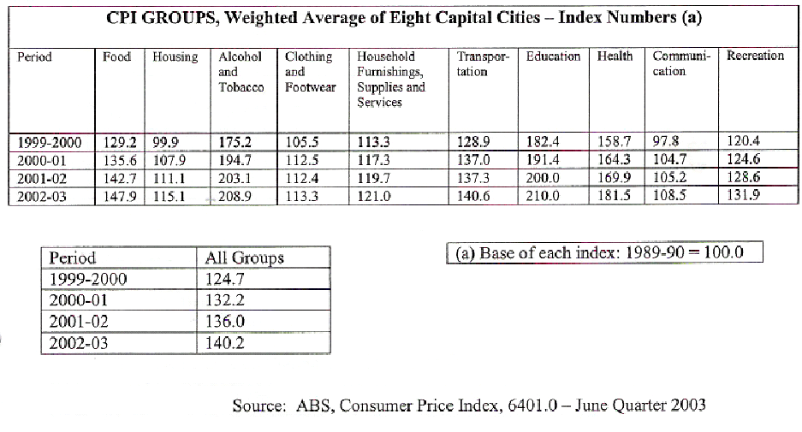

a) Calculate the inflation rate between the years:

i 1999 / 2000 and 2000 / 2001 _____________________________ (1)
ii 2001 / 2002 and 2002 / 2003 _____________________________ (1)

b) In the period 1999 / 2000 to 2002 / 2003 state which group in the CPI
i Recorded the greatest absolute rise in its index _____________________ (1)
ii Recorded the smallest percentage increase in its index _______________ (1)
iii State simply why these different components or groups within the CPI have different weightings attached to them.

_________________________________________________________________________________________________________________________________________________________________________________________________________________(1)

c) Discuss some of the main effects inflation can have in an economy. (5)
______________________________________________________________________________________________________________________________________________________________________________________________________________________________________________________________________________________________________________________________________________________________________________________________________________________________________________________________________________________________________________________________________________________________________________________________________________________________________________________________________________________________________________________________________________________________________________________________________________________________________________________________________________________________________________________________________________________________________________________________________________________________________________________________________________________________________________________________________________________________________________________________________________________________________________________________________________________________________________________________________________________________________________________________________________________________________________________________________________________________________________________________________________________________________________________________________________________________________________________________________________________________________________________________________________________________________________________________________________________________________________________________________________________________________________________________________________________________________________________________________________________________________________________________________________________________________________________________________________________________________________________________________________________________________________________________________________________________________________________________________________________________________________________________________________________________________________________________________________________________________________________________________________________________________________________________________________________________________________________________________________
33. Read the following article and then answer the questions that follow
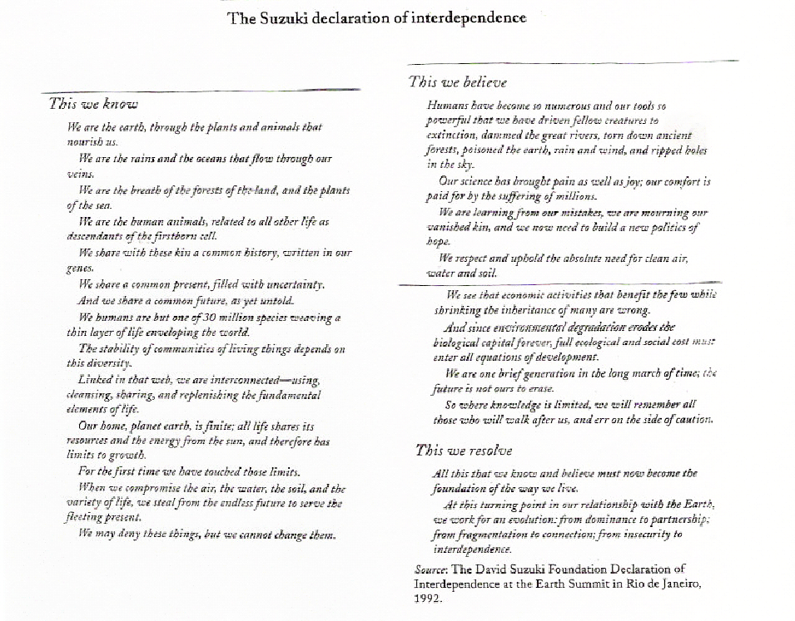
a) What is bio – diversity? and why is it important? (2)
________________________________________________________________________________________________________________________________________________________________________________________________________________________________________________________________________________________________________________________

b) Why is the level and growth of world population an environmental problem? (2)
______________________________________________________________________________________________________________________________________________________________________________________________________________________________________________________________________________________________________________________________________________________________________________________________________
c) Explain the phrase ‘our tools have become so powerful’ (1)
____________________________________________________________________________________________________________________________________________________________
d) What forms of pollution are mentioned in the declaration? (2)
__________________________________________________________________________________________________________________________________________________________________________________________________________________________________________
e) What role do pressure groups play in the protection of the environment? (3)
________________________________________________________________________________________________________________________________________________________________________________________________________________________________________________________________________________________________________________________________________________________________________________________________________________________________________________________________________________________________________________________________________________________________________________________________________________________________________________

SECTION C: EXTENDED WRITING

Answer a total of two (2) questions (40 marks)

Your answer should consist of at least two pages of normal writing.
Suggested time for this section is 70 minutes. Answer the questions of the lined paper provided.

34. (a) Explain how, even with full employment, we can still have hidden unemployment and underemployment. (4)
(b) Describe the major types of unemployment. (8)
(c) Outline the economic and social effects of unemployment. (8)

35. (a) Describe the weaknesses of the market economy and its price system, which lead to
government intervention in the economy. (6)
(b) Discuss the main ways used by the government in Australia to redistribute income. (6)
(c) Outline the main arguments for and against the privatisation of government business
enterprises in Australia. (8)

36. (a) Explain why inflation would cause stock market prices to fall. (3)
(b) What are the factors that effect the share prices. (3)
(c) Explain the usefulness of share price indices to share market traders. (6)
(d) Using appropriate diagram show how the price of a share is governed by the market
forces of demand and supply. (8)

37. (a) Explain how the method of Government intervention in the Australian Agricultural markets has changed in recent years. (8)
(b) Outline any four measures which farmers could use to reduce the pressures of cost price squeeze (4)
(c) Define externalities and using diagrams differentiate between positive and negative externalities. (8)

